Accessing ClassLink from home: Works well when using Google Chrome.

Step 1: Go to the Swift Creek Website = [www.leonschools.net/swiftcreek](http://www.leonschools.net/swiftcreek)  




Step 2: Click on the ClassLink cloud in the top right corner of the webpage.  
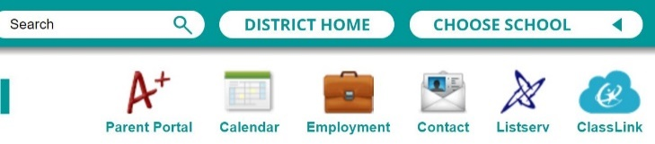



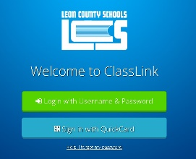

Step 3: Click on the green button to log in to ClassLink



Step 4: It will ask you to type in your credentials. This is your **student email** and **password**.



**Studentnumber@edu.leonschools.net**

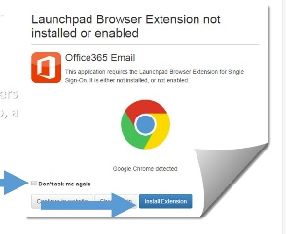When using ClassLink off campus, you may get a message to “Install an Extension”. You will need to do this to open many of the SSO Apps. A prompt will appear to install the app.

Select **“Do not ask me again”**

Select **“Install Extension”**



This will open a new window –Click on “Add to Chrome” 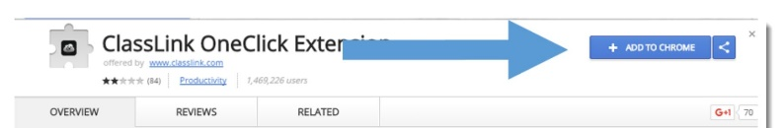



It takes just a few seconds to install. At this point you can close the window and continue using ClassLink.